Kahoot! Gamification in an Accounting Class

Timothy Creel
Lipscomb University
Veronica Paz
Indiana University of Pennsylvania
Christine OLear
Penn State University

Gamification presents an effective way to teach students in a college classroom as they enjoy the competition. Kahoot offers a fun and engaging environment where students can play a game to learn course materials. The Kahoot offers multiple-choice, true or false, or short answer questions along with a puzzle for students to complete. Tips for using Kahoot effectively include keeping it fun, using it to review test or class material, and using the results to find areas where more teaching may be necessary.

Introduction
In today’s college classroom, students bring laptops, tablets, or cell phones into the school, and instructors should be able to lead the use of them to promote student engagement and an active learning environment (Maloy, Edwards, and Evans, 2014). Biddix, Chung, and Park (2015) found that mobile technology in the classroom enhances student engagement, promotes gamification, and improves the in-class learning experience.
One area benefitting from the growth of mobile technology in the classroom is gamification. Gamification involves using games with student participation to help teach course concepts. One of the best tools available today for gamification in the classroom is Kahoot (https://kahoot.com). In Kahoot, a game in the school with students is called a Kahoot. Kahoot allows students to answer questions and earn points playing a fun game in the classroom that consists of different types, including multiple-choice questions or even a puzzle. This paper examines the use of Kahoot in the accounting classroom, including how to get started, its features, and its use as a form of gamification with students to review class material and create a fun and engaging learning process.
Literature Review
Student response systems (SRS) allow students to engage in-class activities by using mobile devices that connect to the internet. The use of SRS in the classroom may include student polling, quizzes, dynamic video presentations, or gamification. With the growth of the digital gaming industry today, it makes sense for instructors to use SRS in their classrooms to improve the learning experience. One way to accomplish this is by gamification. Gamification appears as the use of a game design in a non-game context (Yildirim, 2017). An example would be playing a game with your class that uses mobile technology to help them learn concepts or course material from an educational standpoint.
Research finds many positive aspects to the use of SRS and gamification in the classroom. The benefits of using SRS at the school are improved classroom interactions, an active learning environment, and an engaging classroom environment (Fies and Marshall, 2006). Using student response systems and gamification in the classroom promotes improved attitudes toward student motivation, the learning environment, and outstanding academic achievement (Yildirim, 2017). Urh, Vukovic, Jereb, and Pintar (2015) discovered that gamification in the classroom promoted higher student satisfaction, greater motivation, and higher levels of student engagement in the learning process. Barrio, Munoz-Organero, and Soriano (2015) found that students earned higher grades using SRS and even higher scores when SRS combines with gamification in the classroom.
The use of gamification in the classroom positively relates to the educational needs of students from Generation Z (Biro, 2014). Kahoot promotes a competitive classroom environment. Sailer, Hense, Mayr, and Mandl (2017) found positive effects from badges, performance graphs, and leaderboards during the games. Cakiroglu, Basibuyuk, Guler, and Atabay (2016) found that students had a strong motivation and desire to be on the leaderboard when the top five student scores were listed. Other research found that students were positively motivated by the competition from gamification in the classroom (Barrio, Munoz-Organero, and Soriano, 2015). Biro (2014) discovered that gamification shares some standard features with behaviorist learning theory. Examples include positive reinforcement, immediate feedback to students, and allowing them to face progressive challenges, all of which benefit them today.
Student response systems work in any class, and there are many types of methods available to promote accounting concepts in the classroom. Most SRS and gamification studies examine it from the standpoint of a campus class. Dominquez, Saenz-de-Navarrete, de-Marcos, Fernandez-Sanz, and Pages (2013) show higher overall scores for students who completed the gamification process in an e-learning environment. This study reviews the use of Kahoot! in a classroom environment.
Kahoot offers quizzes to students through a free app on mobile devices or online through laptops or tablets. Recent studies show Kahoot works well with educating today's students. Sabandar, Supit, and Suryana (2018) found Kahoot was fun to engage modern learners. It promoted competition, goal achievement, and self-expression among the learners. Chien-Lin, Yeu-Hui (2018) found Kahoot performed well concerning educating Generation Z learners as it motivated them to participate more in the classroom.
Current research finds many benefits to the use of Kahoot in the classroom. Licorish, Owen, Daniel, and George (2018) studied game-based learning systems and how they promote student engagement and improve the learning experience. Their research using Kahoot found it created a rewarding learning experience, encouraged student participation, aided students in remembering the information, provided a competitive environment, promoted a higher level of student focus, and provided more significant interaction and involvement within the classroom. Yapier and Karakoyun (2017) found it promoted enjoyable class sessions, greater active student participation, and more permanent learning of the course material.
Many of the educational benefits of Kahoot relate to the competitive nature of playing the game. Sabandar, Supit, and Suryana (2018) found the competition increased the students' intrinsic motivation since they desired to win the game. Students' extrinsic motivation increased due to the reinforcement of being listed as one of the top three in the medal area at the conclusion (Yapier and Karakoyun, 2017). Bicen and Kocakoyun (2018) found that Kahoot increased the interest of students in the class. Kahoot made them prepare more for class since they knew they would be tested on the course material and improved their rapid thinking skills since the students scored higher in the game with quicker responses.
Getting Setup in Kahoot
Faculty and students may obtain a free account by going to https://kahoot.com. The free version offers essential functions and limited numbers of student engagement in the Kahoot. Packages with more capabilities are available for purchase, providing more options and allowing more students to participate in the game.
A professor can either build their quiz or find one posted by another professor in the Kahoot library with thousands of available Kahoots. The professor setting up the quiz does have some options when setting up the quiz. Quizzes are available as multiple-choice, true or false, short answer questions, or puzzles students can complete. The professor can assign different lengths of time to questions and can exercise different ways to score the Kahoot, including eliminating points altogether.

Figure 1 – Building a Kahoot
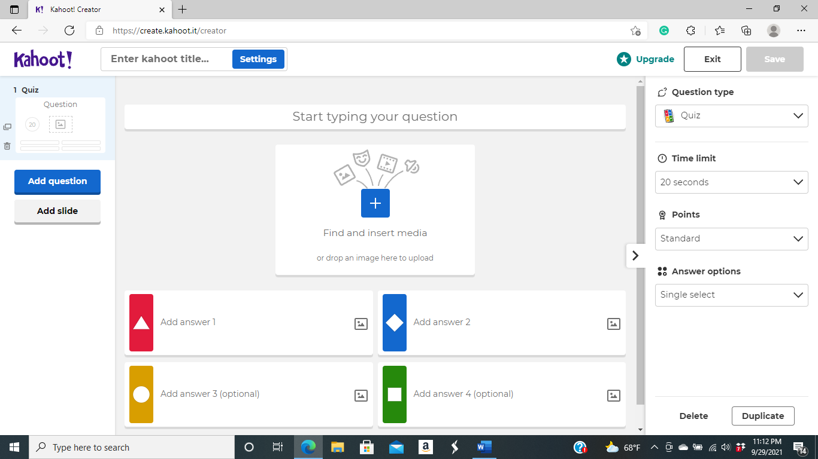

Figure 2 – Kahoot Options for Gamification in the Classroom
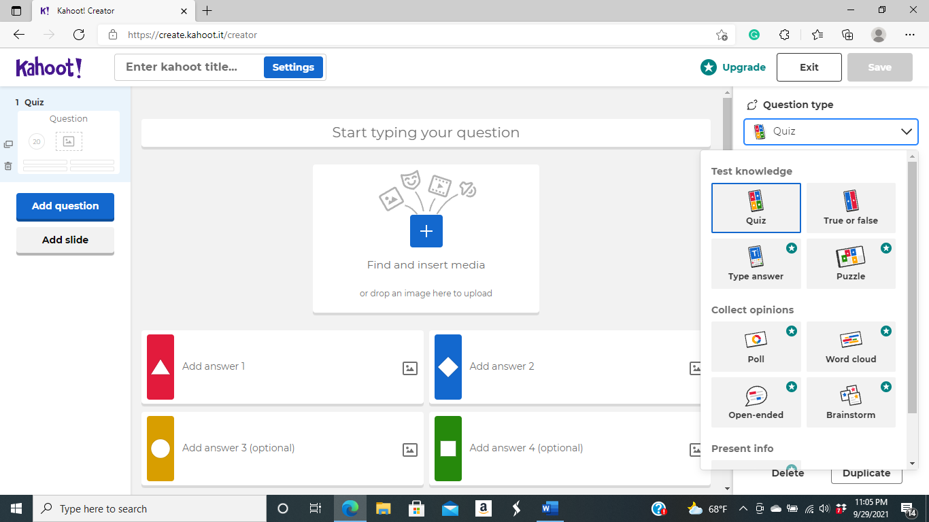

Figure 3 – Sample Kahoot Quiz
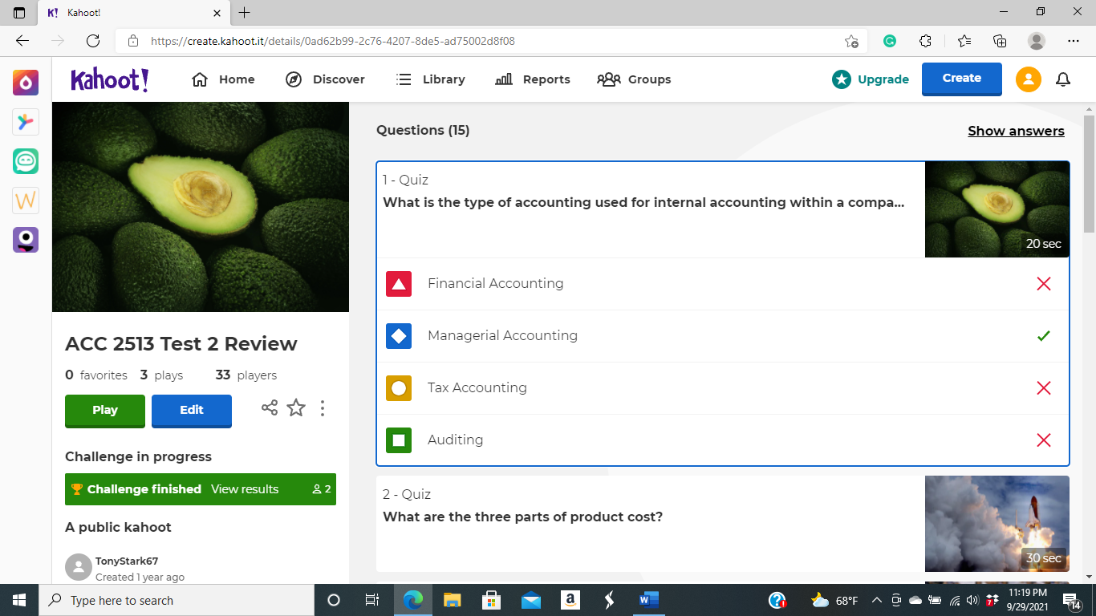

When the Kahoot starts, the student’s login and input the game code to access the class game. The students collect points based on correct answers and score higher based on the speed of making their responses. Music plays, and background pictures appear with each question established by the faculty member. The game will show the top three student scores from the quiz activity once completed on the podium. The faculty member will also access analytics regarding quiz performance, including student scores and the percentages of each question answered correctly. This report will allow the professor to judge how well the class understands the course material.
A Review Tool in the Classroom
There are many ways to use Kahoot as it provides an effective gamification method in a college classroom. The professor can work through a Kahoot quiz with the class during the meeting before an exam. After completing each question, the instructor can go over the solution and review the material covered in the previous question. A professor can also start each class with a short Kahoot to review the prior class meeting material. One professor had a class create their quizzes, and the students felt like this helped them critically consider all parts of the course material (Bryant, Correll, and Clarke, 2017). Based on student performance on the Kahoot, a professor may decide students need a more significant review of some material.
Kahoot offers options for both campus and online courses. The quizzes can be prepared and assigned to online courses. The online students would complete the Kahoot, and the professor can grade the students, use it as a review of course material, or see what areas may need more teaching based on student scores.
Tips for Using Kahoot
After using Kahoot many times in accounting classes, several tips learned may help with its use in the classroom. Ways to help with the successful use of Kahoot include keeping it fun, offering extra credit for the top performers, keeping your questions relevant to the test or material, and including fun or relevant pictures with your Kahoot game.
One is to keep the Kahoot environment fun. Use fun names in Kahoot and encourage the students to do the same. My name in Kahoot is Tony Stark, and students may use superhero names, professional athletes, professional wrestlers, or even professors at the university. The professor can throw out students if they choose a name that is not appropriate for the classroom setting.
Another tip for using Kahoot! in the classroom is to offer extra credit for the top performers. Once the Kahoot is complete, the top three performers will medal on the podium. The practice of offering extra credit and informing students before the game increases the competitive nature of the students. The extra credit provided may be, for example, points added to the next test grade or the student’s final grade in the class.
The questions in Kahoot should be relevant to the material from the course or the material included in the next exam. Keep the questions short as you have limited characters with the free version, but they should cover similar topics as what was covered in class or on the next test. The Kahoot includes 10 to 20 questions depending on how much time you review between the questions if reviewing for a test or three to five questions if reviewing material from the last class. The preparer can give more time for students to answer more extended questions as the time limit is anywhere from 20 seconds to 4 minutes.
The preparer can include pictures with each Kahoot played in class. The program has photos you can choose from, and some may fit the topic, but others are just fun. These include items such as a WWII airplane, baseball players, scenes from nature, or the White House. The professor also can download some of their pictures. Pictures that are fun or fit the question add to the enjoyable aspect of the Kahoot in the same way as the music that plays as students are answering the questions.
Conclusion
Kahoot allows for gamification in a classroom, and many research studies have found positive benefits of using games to teach college students. A professor can set up a quiz known as a Kahoot with music, pictures and create a fun learning experience in the classroom. It is a fun way to review for a test where the professor teaches questions or simply a short Kahoot to review material from the last class session. The Kahoot can be multiple-choice, short answer, true or false, or even created in the form of a puzzle. Tips for using Kahoot effectively include using fun names, pictures, background music, and creating questions that represent the covered material. Overall, Kahoot offers a fun, gamification experience to an accounting or any other type of college class that benefits the students.

References
Barrio, C., Munoz-Organero, M., Soriano, J. (2015). Can Gamification Improve the Benefits of Student Response Systems in Learning? An Experimental Study. Emerging Topics in Computing, 4(3), 429-438.
Bicen, H., & Kocakoyun, S. (2018). Perceptions of Students for Gamification Approach: Kahoot as a Case Study. iJet, 13(2), 72-93.
Biddix, J., Chung, C., & Park, H. (2015). The Hybrid Shift: Evidencing a Student-driven Restructuring of the College Classroom. Computers & Education, 80, 162-175.
Biro, G. (2014). Didactics 2.0: A Pedagogical Analysis of Gamification Theory from a Comparative Perspective with a Special View to the Components of Learning. Procedia – Social and Behavioral Sciences, 141, 148-151.
Bryant, S., Correll, J., & Clarke, B. (2018). Fun with Pharmacology: Winning Students over with Kahoot! Game-based Learning. Journal of Nursing Education, 57(5), 320.
Cakiroglu, U., Basibuyuk, B., Guler, M., & Atabay, M. (2017). Gamifying an ICT Course: Influences on Engagement and Academic Performance. Computers in Human Behavior, 69, 98-107.
Chien-Lin, K., & Yeu-Hui, C. (2018). Kahoot: Applications and Effects in Education. Hu Li Za Zhi, 65(6), 13-19.
Dominguez, A., Saenz-de-Navarrete, J., de-Marcos, L., Fernandez-Sanz, L., Pages, C., & Martinez-H Herraiz, J. (2013). Gamifying Learning Experiences: Practical Implications and Outcomes. Computers & Education, 63, 380-392.
Fies, C., & Marshall, J. (2006). Classroom Response Systems: A Review of the Literature. Journal of Science Education and Technology, 15, 101-109.
Licorish, S., Owen, H., Daniel, B., & George, J. (2018). Students’ Perception of Kahoot!’s Influence on Teaching and Learning. Research and Practice in Technology Enhanced Learning, 13(9), 1-23.
Maloy, R., Edwards, S., and Evans, A. (2014). Wikis, Workshops, and Writing: Strategies for Flipping a College Community Engagement Course. Available at: https://eric.ed.gov/?id=EJ1020077
Sabandar, G. (2018). Kahoot!: Bring the Fun into the Classroom! Indonesian Journal of Informatics Education, 2(2), 127-134.
Sailer, M., Hence, J., Mayr, S., & Mandl, H. (2017). How Gamification Motivates: An Experimental S Study of the Effects of Specific Game Design Elements on Psychological Need Satisfaction. Computers in Human Behavior, 69, 371-380.
Urh, M., Vukovic, G., Jereb, E., & Pintar, R. (2015). The Model for Introduction of Gamification into e- Learning in Higher Education. Procedia-Social and Behavioral Sciences, 197, 388-397.
Yapier, I., & Karakoyun, F. (2017). Gamification in Biology Teaching: A Sample of Kahoot Application. Turkish Online Journal of Qualitative Inquiry, 8(4), 396-414.
Yildirim, I. (2017). The Effects of Gamification-based Teaching Practices on Student Achievement and Students’ Attitudes towards Lessons. Internet and Higher Education, 33, 86-92.

